Control Engineering

Handout – Online Laboratory 3

Name: *Colda Andreea Ariana*

Group: *30332*

Consider the fixed parts: , . Compute the controllers using the Guilemin-Truxal method, if necessary simplify the controller structure and check the performance of the closed loop system using Matlab, for the following performance sets:

a) 

*0.04888 s + 0.02444*

*Hc= -------------------*

*s + 0.2286*

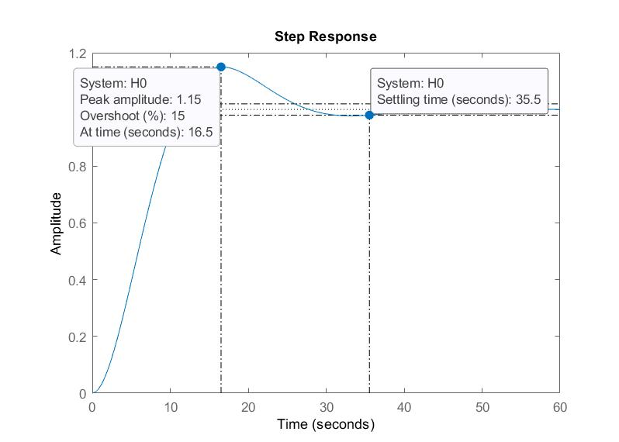

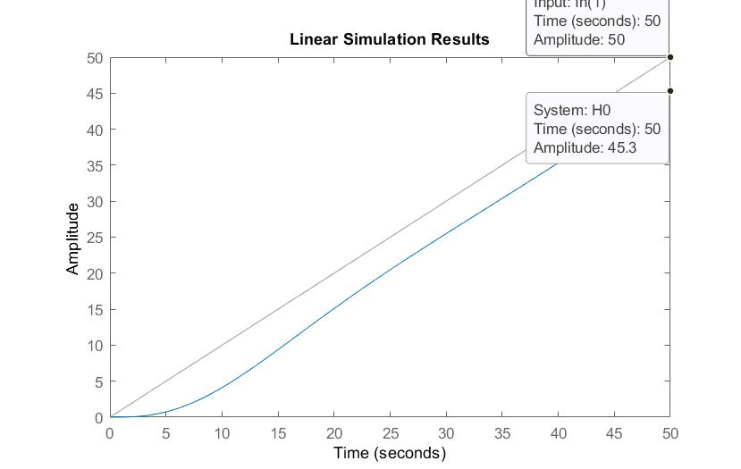

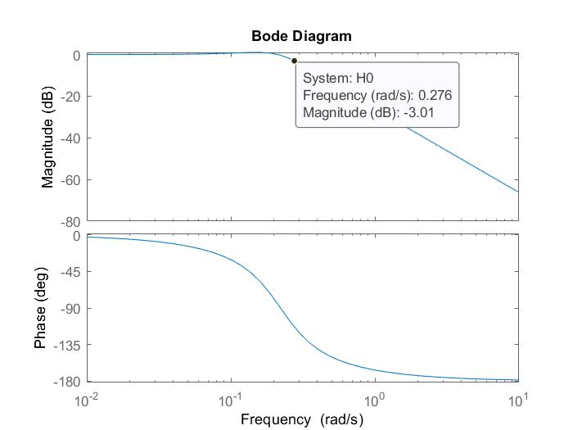

b) 

*1.663 s + 0.8316*

*Hc = ----------------*

*s + 1.333*

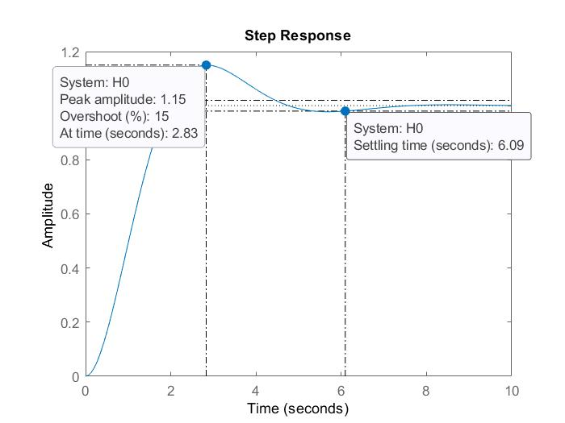

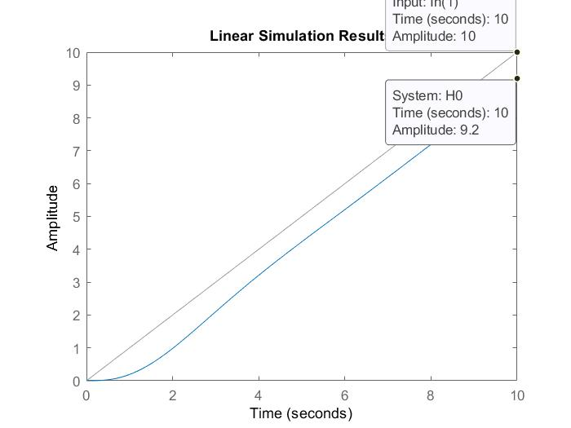

c) 

*We can not find a controller that satisfies all the 5 conditions. Here is one controller that satisfies only 4 of them.*

*11.45 s + 5.723*

*Hc = ---------------*

*s + 4*

*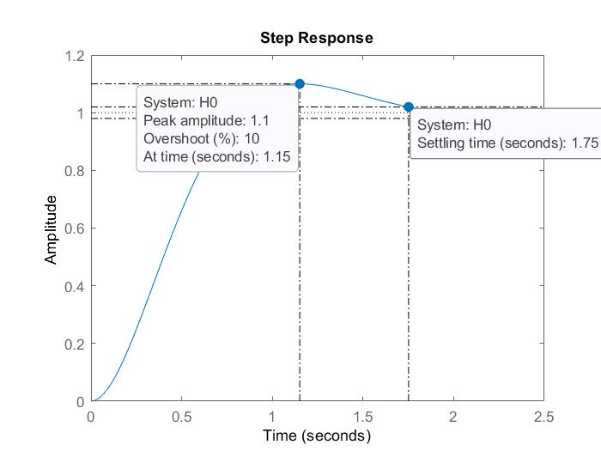*

*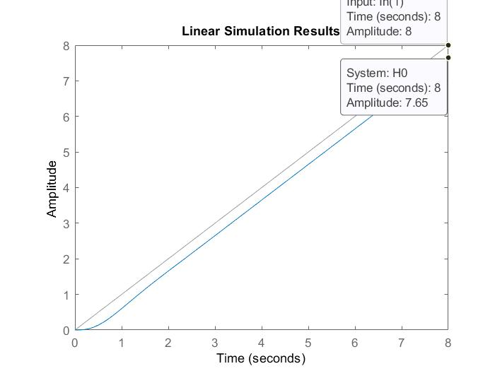*

All done? Great job 🍾🎉🎊! Upload this document along with your Matlab/Simulink files in the Assignments section of the Control Engineering I group in Teams (pay attention to select the correct Assignment!).